# Top 15 city spending in total amount transaction

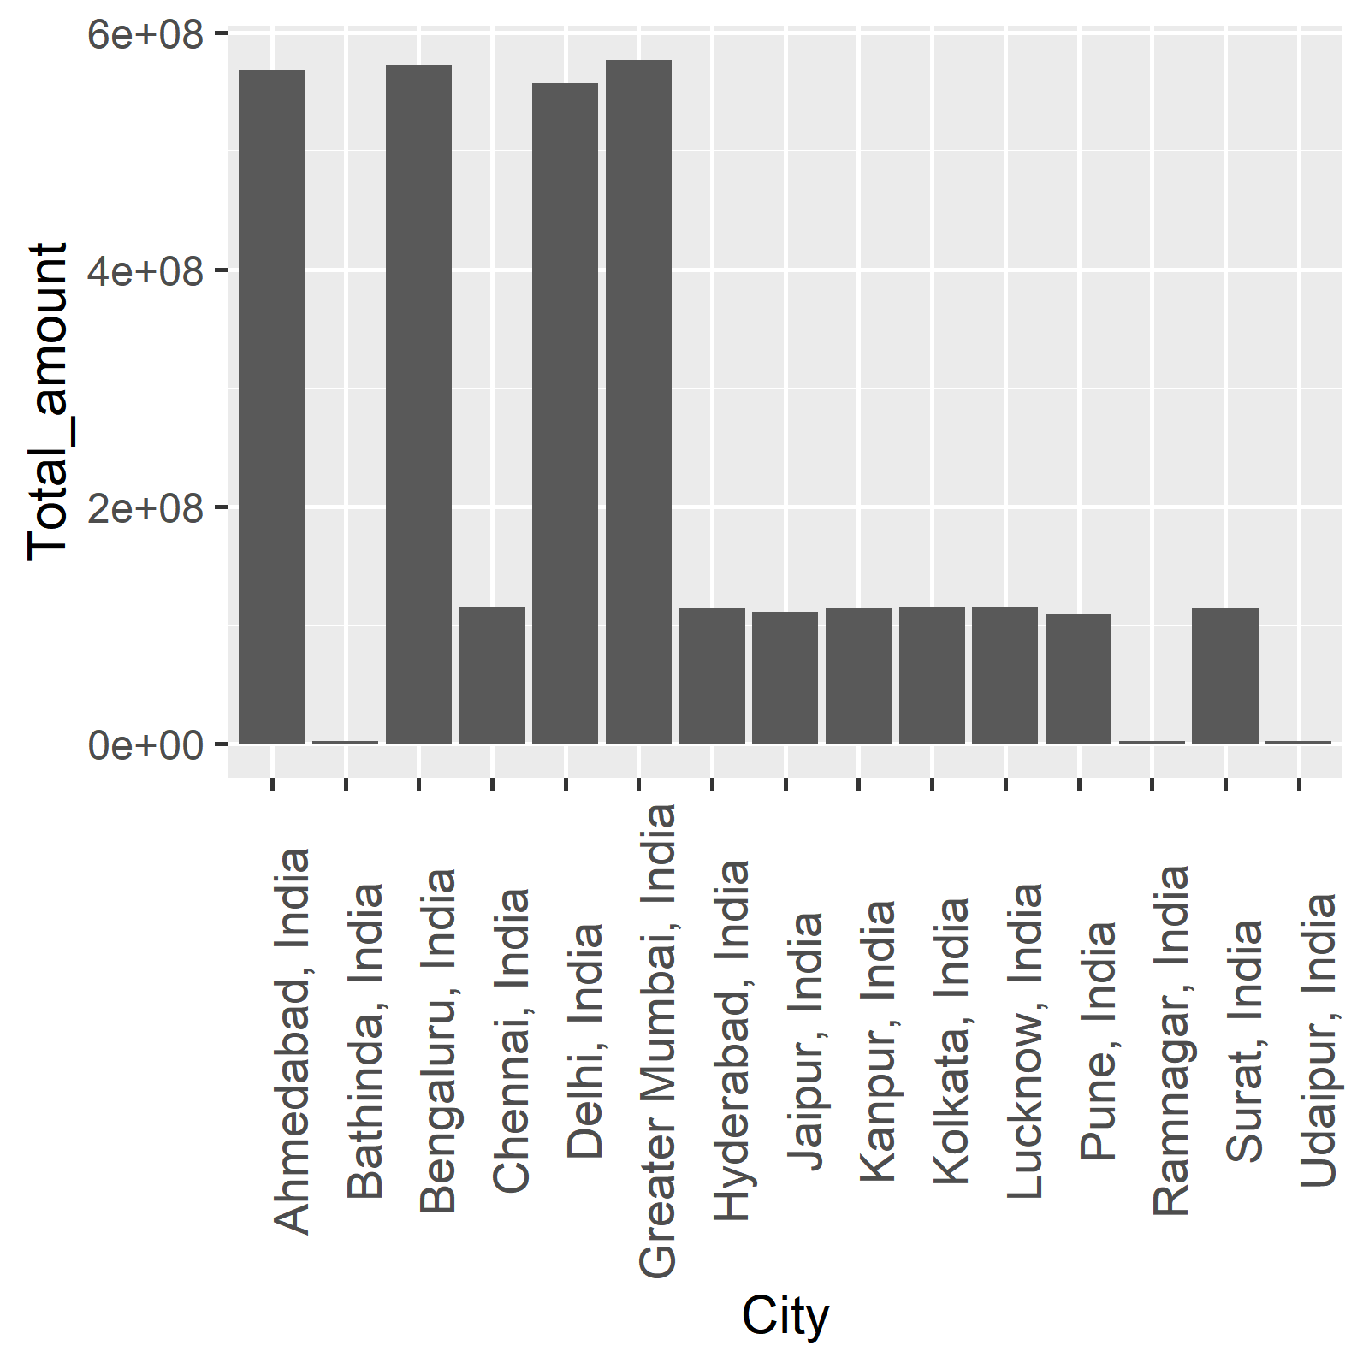

Top 15 spending summarize

| City | Total_amount |
| --- | --- |
| Greater Mumbai, India | 576,751,476 |
| Bengaluru, India | 572,326,739 |
| Ahmedabad, India | 567,794,310 |
| Delhi, India | 556,929,212 |
| Kolkata, India | 115,466,943 |
| Lucknow, India | 115,334,476 |
| Chennai, India | 114,730,600 |
| Hyderabad, India | 114,493,477 |
| Surat, India | 114,486,151 |
| Kanpur, India | 114,370,532 |
| Jaipur, India | 111,136,855 |
| Pune, India | 109,313,930 |
| Bathinda, India | 2,767,609 |
| Udaipur, India | 2,498,194 |
| Ramnagar, India | 2,448,619 |